***Nitin Nagavel***

***CPRE 431***

***M03 HW***

**Assignments will be submitted in PDF format via Canvas.**

Please submit your homework online through Canvas. Late homework will not be accepted.

Please ensure that you support all your answers with the correct screenshots showing your solutions.

1. In this “lab” problem, you will be working on a Linux Server Virtual Machine (VM). An image of this VM is available on Canvas (attached with the HW). The VM is having an administrator and 5 users, as shown in the figure below. You don’t have access to any of the users of the Server, to be able to access the Server, you will need to perform password cracking! You were given a line of password hash from (/etc/shadow) for the administrator (admin1) of the Server (attached with the HW).
   1. Determine the used hash type of the password.

SHA-512

* 1. Determine the salt value of the password.

$xgLS35s6

* 1. Crack the passwords of all users using OpenSSL tool.

Admin1:P@ssw0rd

Hints:

* It would be useful if you search for Linux shadow file password format.
* You must use the latest OpenSSL version 1.1.1x for this problem. It would be helpful to read about creating Linux password hashes using OpenSSL.
* You can use a password list for your cracking. There is a password list of most used 100K passwords, according to NIST attached with the HW.
* You will need to write some code to iterate through the password list (feel free to use any language you prefer).
* After cracking the password, ensure that you can access the Server.

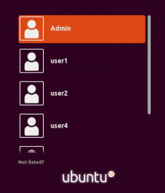

1. The given Server users are managed as follows:

* There are 5 users: user1, user2, …, user5. The first four users are staff members, but user5 is an external consultant.
* User1 and user2 are programmers only, user4 is a manager only, and user3 is both programmer and manager.
  1. You are now the administrator of the server, and you are responsible for managing users and groups. Create 3 groups named “allstaff”, “prog” (short for programmers) and “mgmt” (short for management). Add users to the corresponding groups. List the users and groups to ensure the correct previous setup of system users and groups. Explain with screenshots how you applied this.

* Inside their home directory, each programmer has a directory called code and a directory called documentation. Inside the code directory, there is a file called source_code.txt, as well as one application called myapp.exe. Inside the documentation directory, there is a file called notes.txt.

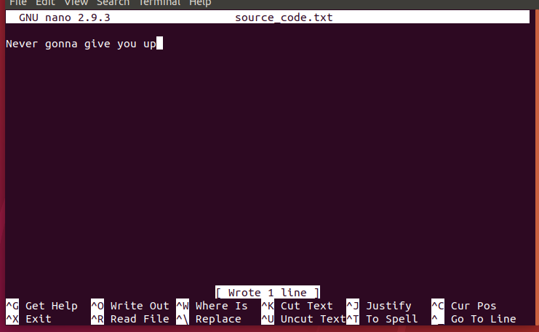

* Each manager has a directory called finance (for financial information) including a confidential business.txt file.

* Each user also has a file called schedule.txt in their home directory.



* 1. Configure file access controls so that it explicitly applies only the following:
* All users can view each other's schedules, but not other files in their home directory (except for as stated in the following).

* All staff can view files in the documentation directory of other staff.

*All users can view the documentation folder shown below:*

* Programmers can view and edit each other's source code files, create new files in any code directory, as well as run each other's myapp.exe files.

*Same for other users in the Prog group:*

* Financial information (in the finance directory) is only viewable by the manager that owns the files, not by any other user.

*User below is the manager that owns the files*

Hints:

* Take screenshots of setting the access and listing it using (ls -l). Also, take screenshots of testing that the access control works by logging in as each user and checking they can(not) access the specified files/directories.
* Use only the basic Linux permissions. Do NOT use advanced permissions such as setfacl or getfacl.
* Use the [“Introduction to Linux” Page](https://canvas.iastate.edu/courses/64200/pages/introduction-to-linux) to help you in the needed commands for this Homework.